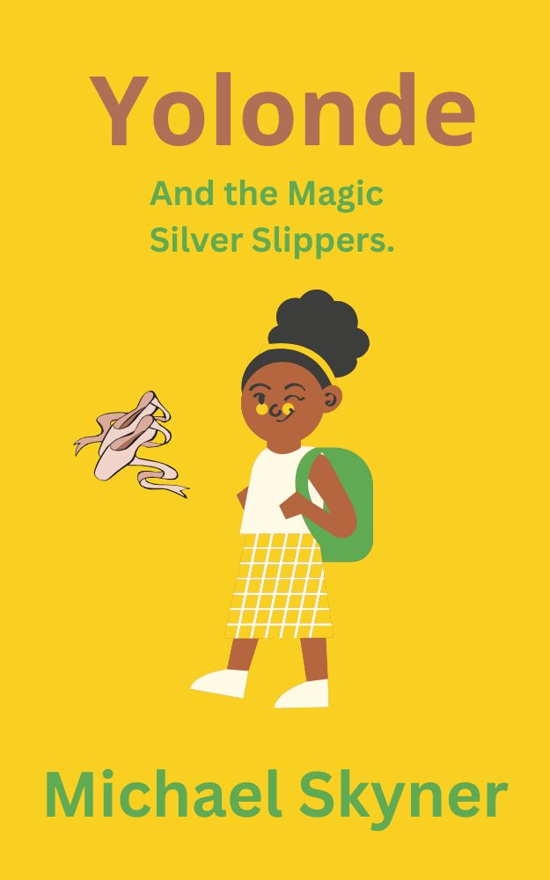

Glossary

Jambo hello
Okra sweet juice drink
Maasai nomadic people
Wali rice dish with coconut
Mandazi Kenyan doughnuts
Boma rural homestead
Ugali thick cornmeal stew.
Gari which means car
Swahili .main language of Kenya
Adumu. dance of the Maasai
Mwombokoa Kikuyu dance which is a dance performed by the elderly
Agikuyu dance which celebrates self-rule
Chakacha another popular dance
Joob JoobTree mythical tree whose fruit is believed to be magical
Savanna huge grasslands
Rift Valley The Rift Valley is part of an intra-continental ridge system that runs through Kenya from north to south of the country.
Somaliland country bordering Kenya
Khanga traditional Kenyan dress
Watusi dance craze popular in the 1960s
Hakuna Matata Swahili for no worries

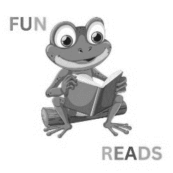

Chapter 1

Katrina

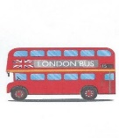

This is me sitting on the number 27 bus going to Tottenham Hale, which is in London, by the way, near the High Street. It’s Saturday, and on Saturday I normally play in the all-girls local football team, though we’re open to boys joining, but so far none have been brave enough. “Not good enough for us girls see,” the coach says.
But not today; today is the first Saturday of the month. I don't play football, so I always go to see my grandma instead. Grandma Wei, Wei, is cool and funny, not stuffy and old-fashioned as some grandmas can be. She is originally from Kenya, where all our family comes from, though I’ve never been myself. Maybe one day I’ll go. Who knows? Kenya sounds like an amazing place, but like everywhere, it has its problems.
Ding ding. I love the sound the bell makes. This is my stop. Grandma Wei, Wei, lives just behind the High Street, close to Woolworths, or what was Woolworths before it closed down. Grandma Wei, Wei, would sometimes take me there and treat me to pick-and-mix sweets when I was little. She now lives in sheltered housing. It is for retired people. Want to come? You won’t regret meeting Grandma Wei, Wei. Here we are number three. I’ll see if she is at home.
Sometimes she goes shopping, but she always leaves a note on the door. ‘Gone shopping back in one hour.’ I tell her she shouldn’t do that, as it tells bad people that there is no one at home. One should not encourage burglars. Grandma Wei, Wei, says I’m just a fusspot and not to worry. She even leaves a spare key under the doormat. The first-place bad people will look. I tell Grandma that she might as well leave a note saying, ‘Dear bad people, please come and take all my things; there is a spare key under the mat just for your convenience.’
Do you know what Grandma Wei, Wei, says to that? I worry too much. OK, whatever, but this is Tottenham you know. To which Grandma Wei, Wei, responds. “Yes, but compared to Nairobi – the capital of Kenya, Tottenham is as safe as the inside of God’s church.” I’m sure that God always manages to lock his door. Anyway, today she’s in.
"Hello Grandma."
"Jambo Katrina, it is good to see you again, child. Come in, come in; I have a treat for you today."
Jambo is Swahili for hello or how are you? We go into the front room, which Grandma calls the parlour. But it is the smells that are coming from the kitchen that really get me excited. I can tell from the aroma that Grandma is making Wali, which is a rice dish with coconut, and it is one of my favourites. But there is something else.
"Grandma, is that mandazi I can smell?" Mandazi are Kenyan doughnuts that are gooey and sticky. They’re delicious and absolutely my all-time favourites. "You know I don’t like doughnuts, don’t you, Grandma?" Grandma Wei, Wei, starts to laugh. A belly laugh so deep it makes her whole body shake and wobble. Like a giant jelly. I laugh too; it’s impossible not to, it’s so catchy.
Finally, the tears of laughter stop, and Grandma Wei, Wei, speaks. "If I don’t get into that kitchen, child, we won’t be having anything for lunch except cold ham." Still chuckling, Grandma Wei, Wei, bustles into the kitchen while I lay the table. Later, we sit on the sofa like a couple of stuffed birds because we are so full. Then Grandma brings out the doughnuts, and it isn’t long before I’m groaning. Four is too much, but I defy you or anyone to resist Grandma Wei, Wei’s, doughnuts. We snooze, and then in the afternoon, we play a game. It’s the same game every time.
I’ve always been fascinated by all the knick-knacks, bits, and bobs that Grandma Wei, Wei, has in her front room. They are all things that remind her of her childhood in Kenya and are her most precious things. The front room is full of them. Grandma Wei, Wei, allows me to choose one and then tells me a story or tale about it.
I don’t know if the stories are true or not, but once Grandma Wei, Wei, begins her story, you do not want her to stop. Last time I was here, I chose a Maasai doll dressed in traditional dress and beads. The colours are amazing. The brightest blues, greens, and reds you’ve ever seen. Grandma told me how the Maasai, who are nomads – that is, people who have no permanent home – would travel hundreds of miles in search of new places to rear their cattle. And they are extremely tall; many are well over six feet, including the women. I am fascinated.
We’ve more or less talked about all the knick-knacks in the room, so I started to ask Grandma about the people in the album of photos she has on a small occasional table. Grandma Wei, Wei, says they are her relatives.
"My family in Kenya; your family, Katrina."
Grandma fascinates me with tales of silly uncles, funny cousins, and her husband, Grandpa Wei, Wei, who sadly passed away ten years ago. But there was one picture that always intrigued me. It is a picture of a young girl in a dancing tutu and silver slippers. She appears to be receiving a big trophy at some big hall. I would often ask Grandma Wei, Wei, about the girl and who she was, but Grandma Wei, Wei, would shake her head and say it’s not important and tell me to find something else. But not today.
"Grandma, you have told me about everything in the room but not who the girl in the picture is. Who is she, Grandma, and what is her story?"
Grandma Wei, Wei, sighed. She looked straight at me. There was a sad look in her eyes. She seemed to be thinking. Finally, she said "You really want to know?
"Yes, Grandma, of course," I said excitedly. I knew there was something special about the girl in the picture, but what it was, I couldn’t say.
"Very well, child, I shall get you some more okra juice and tea for me, and then I shall tell you all about the girl in the picture.
I gulped down my juice and waited expectantly.
"Who is she, Grandma?"
"Her name is Yolonde, and she is the girl with the magic silver slippers."
"The what . . .?”

