Mr Nobody

I’m a nobody

Nobody knows me

I don’t know you

And you don’t know me

How can I be?

If I don’t know who I don’t know

And who I don’t know doesn’t know me

What a funny fella

I must be

This is a picture of me

But nobody knows I’m here.

King Knut

Old King Knut

Sat on his tut

Eating his curds and whey

When along came a hairy Viking

And bashed him on the head

Boy did he have a headache that day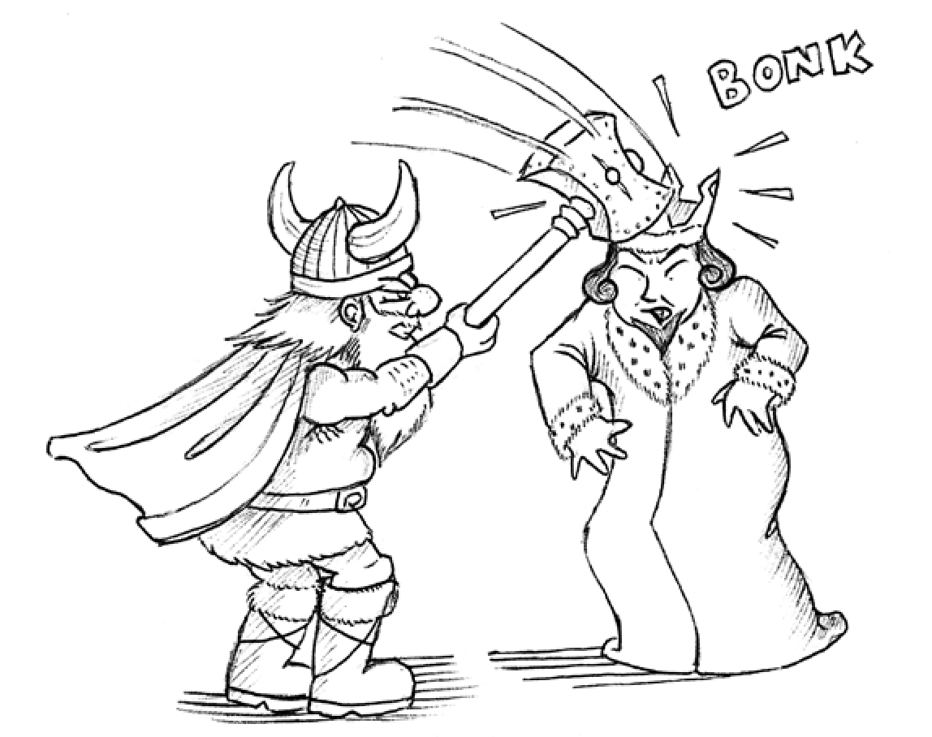

Jolly Jumping Josephit

Jolly Jumping Josephit

Jumped into a jelly pit

It’s a bit smelly he thought

A smelly old jelly pit

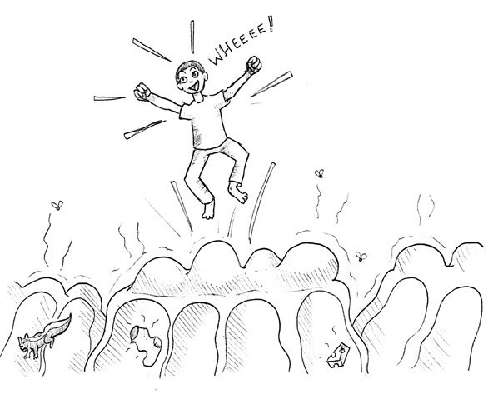

Doggy Doos

My dog does doggy doos

Especially in the park

So, it doesn’t pay to go out in the park after dark

She thinks she’s given me a present

But I tell her it’s not very pleasant

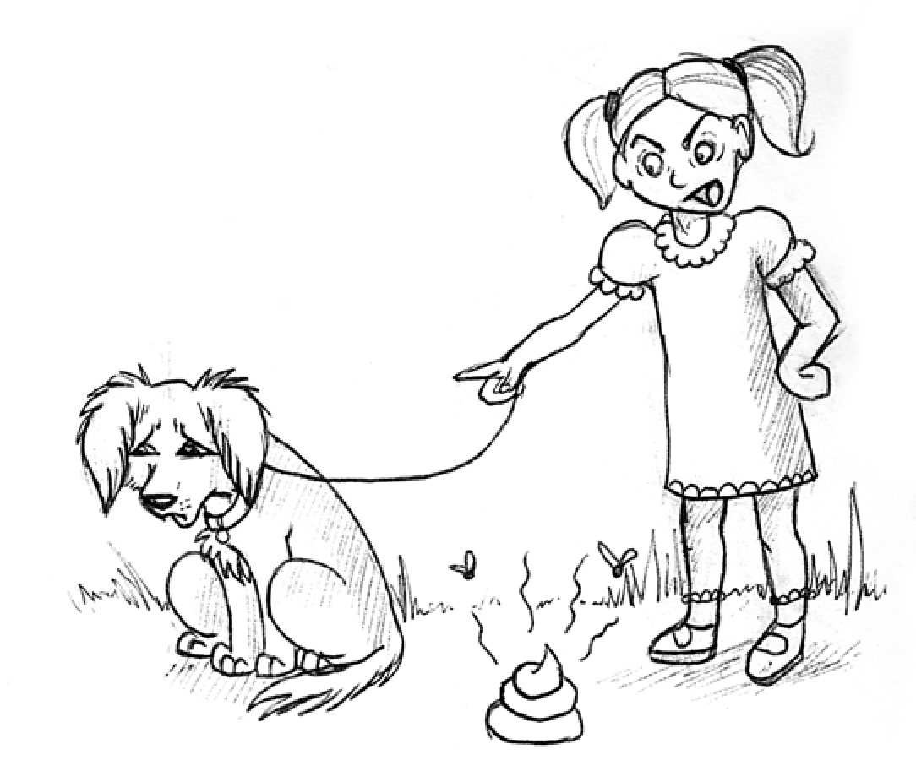

The Big Galoopha

The Big Galoopha went to the park to play

With the children of the day

While he was there, he saw

A stranger talking to a Teddy Bear

So, the police came and took the Teddy

Bear away

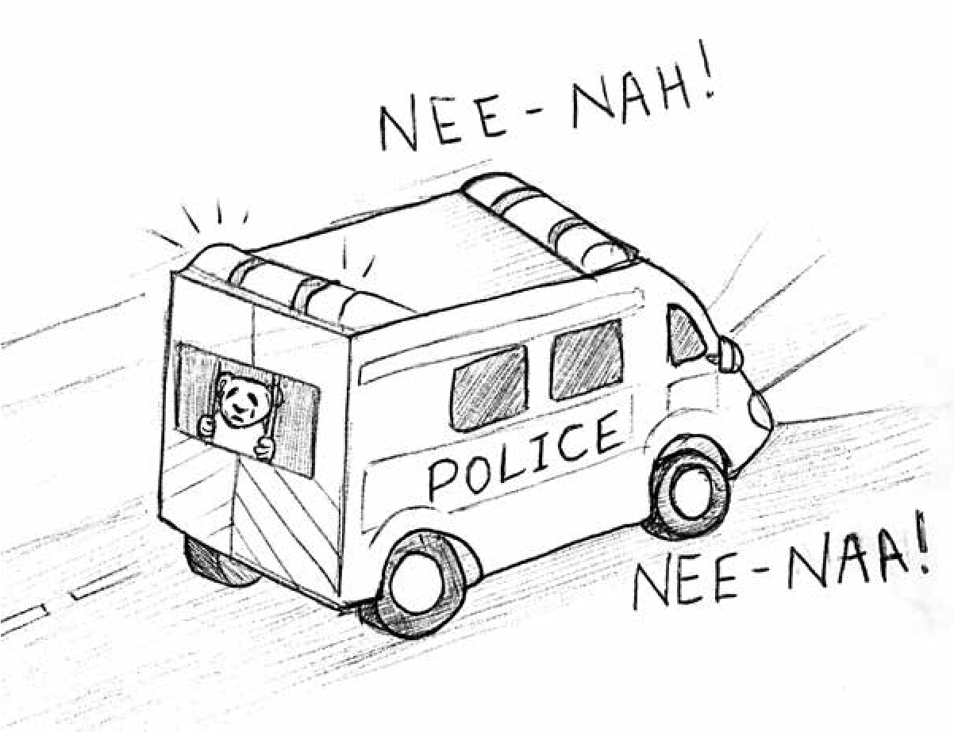

Lembit The Lion

Lembit the Lion

Crawled out of his den

And looked about to see what he ken

Let’s have some fun, thought Lembit

As he started to run

Soon after a fashion

He spied a Macrashion

And thought

Now he’s a good sport

I’ll have him to lunch

But first I will play

So Lembit the Lion bounded hither and thither

While the Macrashion munched nonchalantly away

‘If you are not going to play

I will eat you,’ said Lembit

‘You can’t, I’m too full,’ said the Macrashion

Who had had enough food for one day